**COLLEGE OF BUSINESS EDUCATION**



**DODOMA CAMPUS**

**LIBRARY STORE PROJECT**

***Course* : BIT**

***Lecturer*:MADAM ATUPELE MWAITETE**

***Subject:* PROGRAMMING IN JAVA**

***Nature of Work:* INDIVIDUAL ASSIGNMENT**

***Student name:* ESTHER ISACK SAMWEL**

***Reg No:*  03.2998.01.02.2023**

1. **Introduction**  
   Library store systems (LSS) are essential for the efficient management of libraries, particularly in large institutions such as universities, public libraries, and corporate libraries. A library store system automates the tracking of books, user accounts, and transaction records such as book checkouts, returns, and renewals. Historically, these tasks were handled manually, which often led to inefficiencies, lost books, and disorganized records. By automating the process, libraries can enhance their operational efficiency, optimize resource usage, and ensure timely updates on the availability of books.  
   This report presents the design and implementation of a library store system (LSS) developed in Java, enabling libraries to effectively manage books, users, and transactions. The system supports various functionalities such as adding new books, checking out and returning books, viewing available books, and managing user accounts.
2. **System Overview**  
   2.1 **Objectives of the System**  
   The primary goals of the Library Store system are to:

* Enable the management of books, users, and transactions.
* Allow users to check out, return, and renew books.
* Track available and borrowed books.
* Manage user information, including registration, updating user details, and monitoring transaction history.
* Provide administrators with tools to manage library operations effectively.

2.2 **System Components**  
The system is designed with modular components to handle various aspects of library management. The key components are:

* **Book Class**: Manages book details like title, author, ISBN, availability, etc.
* **User Class**: Manages user details and tracks book transactions for individual users.
* **Transaction Class**: Handles book checkout and return processes, ensuring that book availability is updated correctly.
* **Library Class**: Manages the overall library, including storing books and users, and provides an interface to perform different actions.
* **Admin Interface**: Allows the administrator to manage books, users, and transactions through predefined operations.

1. **Detailed Description of the System Components**  
   3.1 **Book Class**  
   The **Book class** is responsible for storing information about each book in the library. It contains attributes such as:

* **Title**: The name of the book.
* **Author**: The author of the book.
* **ISBN**: A unique identifier for the book.
* **Availability**: A Boolean value indicating whether the book is available for checkout.  
  **Methods**:
* **Check Availability**: Returns the current availability of the book.
* **Update Availability**: Updates the availability status of the book when it is checked out or returned.  
  This class provides the structure for each book, ensuring efficient tracking of the library’s book collection.

3.2 **User Class**  
The **User class** manages user information, including:

* **User ID**: A unique identifier for each user.
* **Name**: The name of the user.
* **Checked-Out Books**: A list that tracks the books currently checked out by the user.
* **Transaction History**: A record of the user's past book transactions (borrowed and returned books).  
  **Methods**:
* **Check Out Book**: Allows a user to check out a book by updating their checked-out books list and the book's availability.
* **Return Book**: Allows the user to return a book, which updates their checked-out books list and the book's availability.
* **Display Transactions**: Displays the history of all transactions (checkouts and returns) for a user.  
  This class ensures that interactions between users and books are tracked effectively, providing a way to manage each user’s library activity.

3.3 **Transaction Class**  
The **Transaction class** manages the checkout and return processes. It contains:

* **Transaction ID**: A unique identifier for each transaction.
* **Book**: The book involved in the transaction.
* **User**: The user who checked out or returned the book.
* **Transaction Type**: Whether the transaction is a checkout or return.
* **Date**: The date the transaction occurred.  
  **Methods**:
* **Process Checkout**: Initiates a transaction when a user checks out a book, updating the book’s availability and adding the transaction to the user’s transaction history.
* **Process Return**: Handles the return of a book, updating the availability of the book and removing it from the user’s checked-out books list.

3.4 **Library Class**  
The **Library class** is the core of the system, managing both books and users. It stores a collection of books and users, provides methods to add or remove books and users, and facilitates the checkout and return processes.  
**Methods**:

* **Add Book**: Adds a new book to the library collection.
* **Remove Book**: Removes a book from the collection.
* **Add User**: Registers a new user in the library system.
* **Remove User**: Removes a user from the system.
* **Find Book**: Searches for a specific book based on title or ISBN.
* **Find User**: Searches for a user based on their user ID.

3.5 **Admin Interface**  
The **Admin Interface** allows administrators to manage the library. It provides operations such as:

* Adding/removing books and users.
* Viewing the status of all books (available, checked out).
* Viewing the transaction history of users.  
  This interface can be implemented using a console-based menu system or as a graphical user interface (GUI) using Java Swing or JavaFX.

1. **System Workflow**  
   4.1 **Adding Books and Users**  
   Administrators can add new books and users. When a new book is added, it is stored in the library’s book collection with all relevant details. When a new user is registered, their information is stored and they are assigned a unique user ID.

4.2 **Checking Out and Returning Books**  
when a user checks out a book, the system checks the book’s availability. If the book is available, it is marked as checked out, and the user’s information is updated to reflect the new transaction. When a book is returned, the system updates the book’s availability and removes it from the user’s checked-out books list.

4.3 **Admin Actions**  
Administrators can view the status of all books, add or remove books from the library collection, and monitor user transactions. They can also search for books and users and generate reports on overdue books or frequent borrowers.

1. **Key Features of the System**

* **Book Management**: Allows administrators to manage a collection of books by adding, removing, and updating book details.
* **User Management**: Administrators can register new users, view user details, and track user activity.
* **Transaction Management**: Tracks each transaction (checkout and return) and updates book availability.
* **Transaction History**: Users can view their transaction history.
* **Admin Interface**: Provides tools for administrators to manage the library efficiently.

1. **Technologies Used**

* **Java Programming Language**: Java is used due to its platform independence, object-oriented design, and rich set of libraries.
* **Java Collections Framework**: Lists and Maps are used to manage books and users.
* **Java IO**: Used for reading and writing transaction data or saving user preferences.

1. **Implementation Challenges**  
   Challenges faced during the development of the Library Store include:

* **Concurrency**: Handling simultaneous operations (e.g., checking out multiple books at once) required careful management to ensure data consistency.
* **Transaction Management**: Properly recording transactions and maintaining accurate book availability required careful attention to detail.

1. **Future Enhancements**  
   Future versions could include:

* **Web-based Interface**: The system could be accessed via a web interface, enabling users to check out books remotely.
* **Barcode Integration**: Barcode scanning could make checkouts and returns faster and more accurate.
* **Fine Management**: The system could track overdue books and calculate fines.

**OUTPUT OF THE JAVA PROJECT**

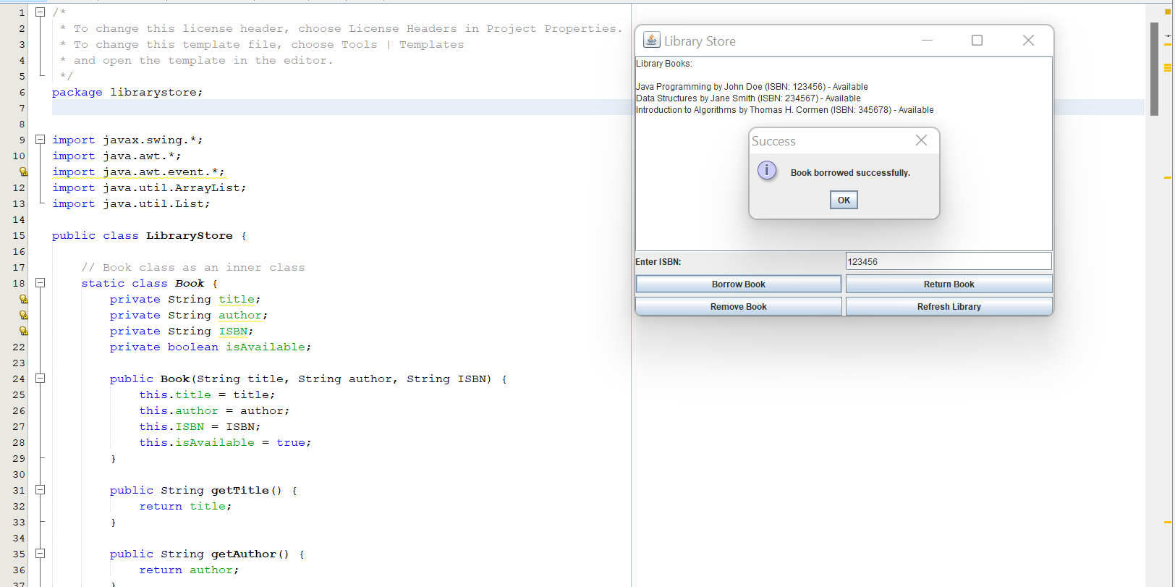

**Conclusion:**

The Library Store is a powerful tool that automates the management of books, users, and transactions. It improves library efficiency, ensures accurate tracking of book availability, and enhances user experience. Future updates can make the system even more user-friendly and accessible.